Chapter 17, Solution 26.

Find the Fourier series representation of the signal shown in Fig. 17.64.

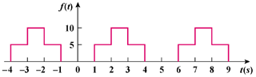

Figure 17.64
For Prob. 17.26.

Solution

T = 4, ω_{o} = 2π/T = π/2

a_{o} = = 1

a_{n} =

a_{n} =

=

=

b_{n} =

=

=

=

Hence

f(t) =

